## Chapter 4: Diurnal and seasonal multi-omic integration with physiological data.

In the last two chapters, an in-depth analysis and discussion have been carried out on rhythms present in proteins and transcripts abundance profiles. Distinct behaviors between the proteome and the transcriptome, with patent time offsets have been identified. These observations emphasize the significance of both transcriptional and post-transcriptional regulation in governing biological rhythms in particular and the biology of an organism in general. In order to attain a comprehensive understanding of how some biological processes are regulated by seasonal variations in diel cycles, it is imperative to integrate the above mentioned multi-omic data with the dynamics of physiological processes. Such integration serves not only as a biological validation of computational omics analysis but also as a crucial component in unraveling the intricate organization present in biological systems in general and the response to diel cycles in particular.

### Cell Division Cycle (CDC) of *Ostreococcus tauri* under seasonal variations in diel cycles

The cell division cycle (CDC) is a highly regulated sequence of processes that govern cell proliferation being conserved across eukaryotes. The impact of diel cycles on cell division has been studied in various phyla, including plants and microalgae such as *Chlamydomonas, Euglena* and *Gonyaulax* (Bruce, 1970; Edmunds & Laval-Martin, 2019; Fung-Uceda et al., 2018; Homma & Hastings, 1989)⁠ as well as in mice and humans (Fu et al., 2005; Matsuo et al., 2003)⁠.

Nevertheless, the confirmation that circadian regulation controls cell division has been a topic of controversy in some organisms, such as the common microalgae model organism, *Chlamydomonas reinhardtii.* While some studies have concluded that the cell division cycle of this microalgae is subject to circadian regulation (Bruce, 1970)⁠, others have proposed that the observed periodicity is linked to cyclic changes in energy status, resulting from circadian regulation of photosynthesis (Spudich & Sager, 1980)⁠.

Currently, it is widely accepted the existence of patent evidence regarding direct regulation exerted by the circadian clock over cell cycle progression in nearly all organisms, including photosynthetic ones. This regulation has been shown to persist under free-running conditions and present the ability to synchronize with different photoperiods (Roenneberg & Merrow, 2005)⁠, regardless of photosynthetic capacity. The cell division cycle, therefore, possesses a complex regulatory mechanism comprising robust circadian clock regulation as well as light-dependence in photosynthetic organisms, since light serves as their primary energy source. (Goto & Johnson, 1995; Hagiwara et al., 2002; Moulager et al., 2007, 2010)⁠. In line with the results presented in Chapter 2, the expression patterns of DNA replication genes remained rhythmic under constant light (ANEXO), while their rhythmicity was disrupted being strongly repressed under constant darkness similar to previously reported results (Roenneberg & Merrow, 2005). This observation supports the notion that a light stimulus is necessary to sustain rhythmicity under free-running conditions, which is in agreement with the complex regulatory mechanism that the cell division cycle (CDC) present in photosynthetic organisms.

The CDC of *Ostreococcus* follows the typical phases of a simple binary fission. Initially, there is a Gap 1 (G1) phase that is dependent on the light-energy status, during which the cell undergoes growth and commitment occurs (Moulager et al., 2007)⁠. In cell division cycle studies, the term commitment refers to the moment when the cell, taking into consideration its energy status, decides whether is ready or not to continue with the progression of the cell division cycle. Once cells are committed, cell division is not impaired by darkness. Consequently, if commitment is achieved, G1 phase is followed by the DNA Synthesis or S phase where DNA replication takes place. The initiation of the S phase is typically timed several hours after sunrise (Moulager et al., 2007, 2010)⁠. After DNA replication is completed, cells enter the final Gap 2 and Mitotic (G2|M) phase, where they prepare for cell division (G2) and undergo mitosis (M). These two phases are often considered together since they are the shortest and most challenging to distinguish using common techniques.

In all eukaryotes, the progression of cells through the cell division cycle is controlled by cyclins and cyclin-dependent kinases (CDKs). *Ostreococcus tauri* possesses an extremely limited set of cyclins and CDKs, with only a single copy of each gene (Robbens et al., 2005)⁠. Additionally, the genome of *Ostreococcus* contains a canonical cell division control protein 25 (CDC25), which is not present in plants (Khadaroo et al., 2004)⁠, and a plant-specific CDKB (Corellou et al., 2005)⁠.

In the preceding chapters, genes and proteins involved in DNA replication (S phase) have been highlighted several times. Now, in order to validate these observations, an estimation of the distribution of cells in each phase over diel cycle was conducted. This integration unveils the adaptation of the cell division cycle in *Ostreococcus* to different seasons and contributes to unraveling the molecular mechanisms of circadian regulation of cell division in microalgae.

#### Temporal program of cell division cycle under summer and winter photoperiod

The phases of the cell division cycle were determined by estimating the DNA content of cells through flow cytometry, and the division of chloroplasts was observed using fluorescence microscopy, as outlined in Materials and Methods section. The rhythmicity analysis was conducted using data obtained from samples collected over three consecutive days under light-dark cycles.

During the summer photoperiod, the G1, S, and G2|M phases exhibited noteworthy rhythmic profiles, with p-values of 9.14x10-6, 4.45x10-6 and 1.53x10-3, respectively. Conversely, under the winter photoperiod, only the G1 and S phases demonstrated significant rhythmicity, with p-values of 9.07x10-6 and 8.69x10-4, respectively. Consistent with the findings from transcriptomic and proteomic analyses, a decline in synchronization, characterized by a reduction in amplitude, was evident under winter short day photoperiod conditions (Fig. 33-A). The reduction in amplitude was so substantial in the G2|M phase that the RAIN package used in the rhythmicity analysis failed to detect a rhythmic profile. These observations suggested that the cell division cycle of individual cells within the culture was more synchronized during the summer photoperiod, which would align with the higher synchronization under this condition that has been also found at the transcriptomic level and presented in Chapter 2. The few hours of light also seem to have a direct effect on cell cy progression of the cell cycle, since a significant reduction of approximately 24% in the number of committed cells was observed under winter photoperiod. Additionally, significant backward shifts of approximately 4 hours were observed in the cell cycle phases under winter photoperiod (Fig. 33-A). These observations are consistent with the observed backward shifts in the time points when transcript and protein abundances reached their maximum levels in response to photoperiod shortening.

The mean percentage of cells involved in G1, S and G2|M phases was calculated for each time point, allowing the characterization of the temporal progression of the cell division cycle in Ostreococcus under different photoperiods (Fig. 33-B,C). Under summer photoperiod, G1 phase predominantly occurred during the light hours, with the maximum percentage of cells in this phase coinciding with the maximum irradiance hours (around ZT8). After commitment, the percentage of cells in G1 phase gradually decreased, while the percentage of cells in the S phase increased. Most cells were in the S phase around sunset and the first part of the night (ZT16-ZT20). Subsequently, the percentage of cells in the G2|M phase gradually rose as DNA duplication was successfully accomplished. The transition from the G2|M to G1 phase, took place during the first part of the morning (ZT4). This indicated that cell division or mitosis in Ostreococcus mainly occurred after sunrise under summer long photoperiods (Fig. 33-B).

During winter short photoperiods, consistent with the observations made in the summer long photoperiods, the G1 phase coincided with maximum irradiance hours (ZT4 under winter short photoperiods) and the S phase occurred 4 hours after sunset (around ZT8). However, the G2|M phase not only adapted to the photoperiod but also underwent a reorganization to anticipate the limited daylight hours ahead. Under short winter photoperiods, the G2|M phase exclusively occurred by night. As soon as the sun rises, cell division was completed, allowing cells to undergo growth in the morning. These findings suggested that the cell division cycle was strongly influenced by the circadian clock and could anticipate cyclic changes, such as the reduced duration of light during winter short photoperiods. To ensure this anticipation, the circadian clock ensured that all cells entered the G1 phase precisely at sunrise, maximizing the utilization of available daylight hours (Fig. 33-C). This anticipation was also observed in chloroplast division. Under summer long photoperiods, chloroplast duplication was achieved during the latter part of the night (ZT20) (Fig. 33-D), while under the winter photoperiod, it took place at ZT16. Before sunrise, a substantial number of cells already possessed only one chloroplast during winter short photoperiods (Fig. 33-E).

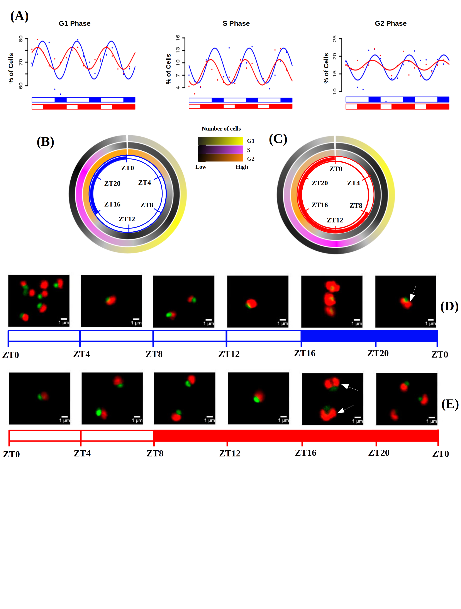Figure 33. **Cell division cycle (CDC) of Ostreococcus tauri under summer and winter photoperiod.** (A) Percentage of cells in G1, S and G2|M phases during the three days of sampling. Points correspond to real data and lines represent waves approximations made by Circacompare during the rhythmicity analysis. (B-C) Circular heatmap representing mean percentage of cells in G1, S and G2|M phases during summer and winter photoperiod, respectively. (D-E) Photographs of cells under the fluorescence microscope. Each photograph correspond to a different time point of summer and winter photoperiod, respectively. Nucleus are dyed and they fluorescence in green, chloroplast in red. White arrows point cells that posses two chloroplasts due to chloroplast division prior to cell division.

#### Integration of CDC programme with transcriptomic and proteomic data.

*Ostreococcus tauri* annotated genes involved in cell division cycle were organized in three different groups in order to mark in which phase of the cell cycle they are present, according to the current cell cycle model in plants (Carneiro et al., 2021)⁠ (Table. 7, 8, 9).

Table 7: Proteins that are present during the G1 phase of the cell division cycle in Ostreococcus and the corresponding genes that encode them.

|  |  |
| --- | --- |
| **Gene IDs** | **Protein names** |
| O  ostta18g01570 | CYCD |
| ostta04g00110 | CDKA |
| ostta04g01050 | CDC6 |
| ostta16g02100 | Rb |
| ostta02g01950 | E2F |
| ostta10g01190 | Dp |
| ostta08g02940 | DEL |
| ostta04g05220 | ORC1 |
| ostta15g02820 | ORC2 |
| ostta16g01070 | ORC3 |
| ostta11g01820 | ORC4 |
| ostta03g02760 | ORC5 |

Table 8: Proteins that are present during the G2|M phase of the cell division cycle in Ostreococcus and the corresponding genes that encode them.

|  |  |
| --- | --- |
| **Gene IDs** | **Protein names** |
| ostta01g06150 | CYCB |
| ostta15g00670 | CDKB |
| ostta06g02700 | APC1 |
| ostta11g00730 | APC2 |
| ostta06g00360 | APC3 |
| ostta02g03470 | APC4 |
| ostta06g04290 | APC5 |
| ostta01g01000 | APC6 |
| ostta07g02520 | APC8 |
| ostta10g02910 | APC10 |
| ostta11g03040 | APC11 |
| ostta04g04580 | Cdc20 |
| ostta02g03080 | Cdc25 |
| ostta13g02370 | CDH1 |
| ostta08g02230 | FTSZ1 |
| ostta07g01610 | FTSZ2 |

Table 9: Proteins that are present during the S phase of the cell division cycle in Ostreococcus and the corresponding genes that encode them.

|  |  |
| --- | --- |
| **Gene IDs** | **Protein names** |
| ostta02g00150 | CYCA1 |
| ostta18g01570 | CYCA2 |
| ostta11g00910 | MCM2 |
| ostta02g00690 | MCM3 |
| ostta14g01050 | MCM4 |
| ostta11g01760 | MCM4-2 |
| ostta04g00450 | MCM5 |
| ostta01g02580 | MCM6 |
| ostta02g02010 | MCM7 |
| ostta12g01020 | MCM8 |
| ostta14g01690 | GINS1 |
| ostta02g00490 | PSF2 |
| ostta16g02410 | GINS3 |
| ostta04g00390 | SLD5 |
| ostta02g00500 | RFC1 |
| ostta02g00555 | RFC2 |
| ostta09g00990 | RFC4 |
| ostta07g02710 | RFA |
| ostta02g03430 | DNA polymerase II |
| ostta05g00150 | DNA polymerase III γ |
| ostta08g00710 | DNA polymerase α |
| ostta11g01400 | DNA polymerase α |
| ostta11g01400 | DNA polymerase α |
| ostta07g02610 | DNA polymerase δ |
| ostta08g03680 | DNA polymerase α/ε |
| ostta12g00110 | DNA polymerase α/ε |
| ostta11g01840 | DNA polymerase ε |
| ostta06g02890 | PCNA |
| ostta08g01110 | DNA primase |
| ostta11g00940 | DNA primase |
| ostta13g02040 | DNA primare |
| ostta08g02290 | XPG |
| ostta10g00340 | DNA helicase |
| ostta10g00640 | DNA ligase |
| ostta13g01140 | RPA replication protein A |
| ostta10g00670 | Wee1 |
| ostta07g01870 | Cks |

Cyclin D and CDKA are present specifically during the first part of the G1 phase. Therefore, they are considered essential proteins associated with G1, facilitating the transition between G2|M to G1 phase and, thus, the progress of the cell cycle. Transcription factors like E2F and Dp as well as other proteins (Rb, cell division control protein 6 and ORCs) are also involved in G1 phase, playing a crucial role in the activation of genes associated with the S phase (Table 7).

In order to start the S phasethe presence of the Cyclin A (CYCA) is required. Concurrently, there is a coordinated expression of polymerases and replication-related proteins (such as MCM complexes, replication factors, PCNA, primases, helicases, ligases, and others) that are essential for DNA replication (Table. 9). The onset of the G2|M phase is marked by the presence of Cyclin B (CYCB), along with subunits of the anaphase-promoting complex (APC) and cell division control proteins (CDC20 and CDC25) (Table. 8) (Carneiro et al., 2021; Moulager et al., 2007, 2010; Robbens et al., 2005)⁠⁠.

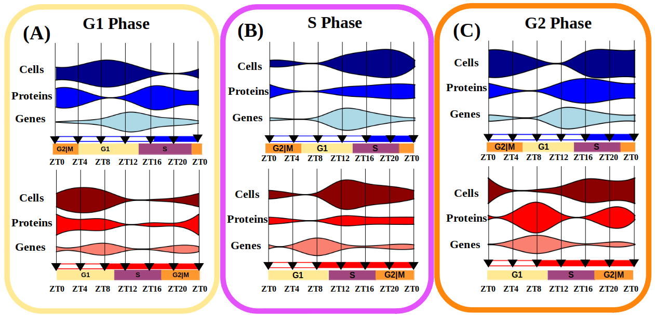Figure 34: **Integration of gene expression, protein abundance and cell population profiles for each phase of the cell cycle.** Violin plots represent the three biological levels studied: “Genes” for transcriptomic data, “Proteins” for proteomic data and “Cells” for DNA content estimation by flow cytometry. (A) Involves G1 phase related data, (B) S phase and (C ) G2 phase.

Gene expression and protein abundance profiles were integrated with the percentage of cells in each phase of the cell cycle in which the corresponding genes and proteins were present (Fig. 34). In addition to the globally observed gene-protein offset, an overall offset was also identified between protein abundance and the execution of their physiological role. Notably, this offset appeared to be more pronounced in certain phases such as G1 or G2|M (Fig. 34-A, C). However, during the S phase, once the proteins were available, the corresponding biological processes were promptly executed, resulting in a shorter offset between protein and physiological execution (Fig. 34-B).

The transcriptomic and proteomic data for cyclins and CDKs found in *Ostreococcus* (Fig. 35) were in agreement with the current cell cycle model for plants (Carneiro et al., 2021)⁠. In both summer and winter photoperiods, the transcription of the CYCD, that will trigger the start of the S phase, occurred during the G1 phase and it was the first cyclin to be activated. It has been suggested that Cyclin D is predominantly regulated by the circadian clock, as it has been shown to be independent of metabolic status (Moulager et al., 2010)⁠. Consistent with those findings and previous transcriptomic analyses (Carneiro et al., 2021; Moulager et al., 2007)⁠, the expression of Cyclin D (during G1 phase) presented a strongly rhythmic expression profile that was followed by the expression of Cyclin B (during the S phase) (Fig 35-A).

Cyclin proteins were not detected in our proteomic analysis, but CDKA and CDKB protein abundance profiles were detected and their abundance profiles are in agreement with the proposed model (Carneiro et al., 2021)⁠. The expression of CDKA encoding gene reached its maximum level during G1, preceding an increase in CDKA protein abundance during the latter part of the G1 phase (Fig. 35-B). This increase, in conjunction with Cyclin D, facilitated the progression of the cell cycle into the S phase. During the S phase, the abundance of CDKB protein reached its maximum level (Fig. 35-C), coinciding with Cyclin B transcript levels. The transcript levels of Cyclin A were relatively low under both photoperiods, but their peak of expression aligned with the G2|M phase (Fig. 35-A). Genes involved in chloroplast division, such as Filamentous Temperature-Sensitive Z (FtsZ, ostta07g01610), play central roles in the G2|M phase. It represents a crucial protein that has been conserved from its cyanobacterial ancestors (TerBush et al., 2013)⁠. FtsZ presented protein peaks reached during the transition S/G2|M phase (at sunrise, ZT0, in summer photoperiod and during the night, ZT16, in winter photoperiod) (Fig. 35-D). Confocal microscopy images validated these findings by identifying cells with two chloroplasts as a result of recent divisions at ZT20 under LD condition and ZT16 under SD condition (Fig. 33-D,E).

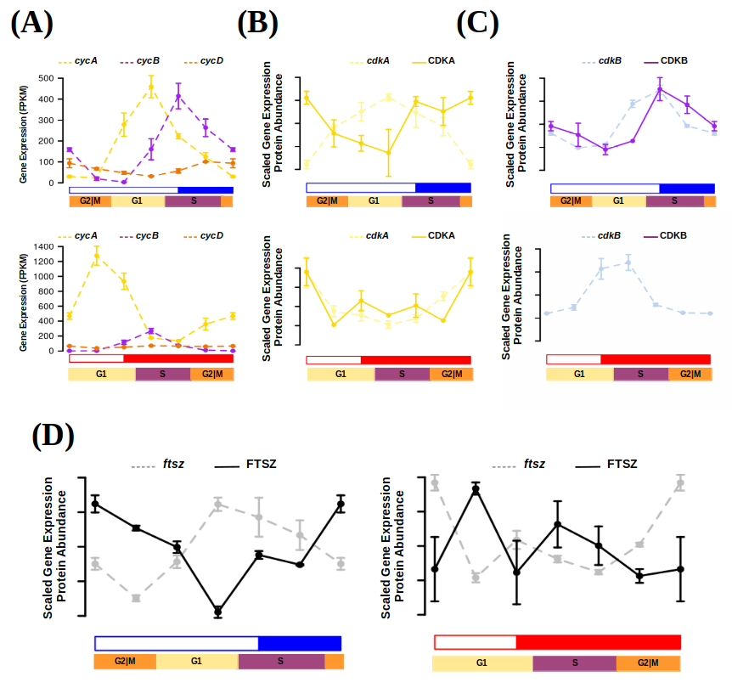Figure 35: **Transcript and protein abundance profiles of the main cell cycle proteins under summer and winter photoperiod in Ostreococcus tauri.** (A) Expression level of cyclins A (yellow), B (purple) and D (orange) genes are represented with discontinued lines under summer (blue) and winter (red) photoperiods. Transcript (discontinued line) and protein (solid line) abundances of CDKA are represented in yellow (B), CDKB in purple (C) and FTSZ in black (D).

### 

Diurnal and seasonal rhythm of photosynthesis in *Ostreococcus tauri*

Photosynthesis constitutes a fundamental process for plants, wherein oxygen (O2), adenosine triphosphate (ATP), and reduced nicotinamide adenine dinucleotide phosphate (NADPH) are generated from water (H2O) and light. The generated oxygen is released into the atmosphere, while ATP serves as an essential energy source for cellular processes. Moreover, NADPH plays a crucial role as a reducing agent, facilitating assimilatory processes such as the Calvin cycle, which mediates the fixation of atmospheric carbon dioxide (CO2) into organic carbon compounds.

Within the genome of *Ostreococcus tauri*, all the indispensable proteins implicated in the electron transport chain of photosynthesis and carbon fixation are present. However, the number of copies in *Ostreococcus* islower when compared to plants and other microalgae. Notably, the composition of light-harvesting complexes in *Ostreococcus* exhibits distinct characteristics. While light-harvesting complex proteins associated with photosystem I (LHCI) are present, LHCII are lacking. Instead, specific chlorophyll-binding proteins unique in prasinophytes are identified in *Ostreococcus* (Blanc-Mathieu et al., 2014; Derelle et al., 2006)⁠. This observation suggests the presence of LHCI within the green lineage from an evolutionary stage prior to *Ostreococcus* ancestors (Six et al., 2005)⁠.

Understanding how photosynthesis adapts to diurnal and seasonal cycles can contribute to develop systems enhancing microalgae productivity, which is a relevant topic in microalgae biotechnology. The circadian regulation of photosynthesis was initially documented in marine algae, with the observation of circadian oscillations in oxygen production (Dodd et al., 2014; Sweeney & Haxo, 1961)⁠. After that discovery, circadian oscillations in various physiological phenomena associated with photosynthesis, including chloroplast ATP concentration, electron transport rate, starch content, and photosynthetic efficiency, have been observed in microalgae (Mackenzie & Morse, 2011; Ral et al., 2006; Sorek et al., 2013; Sweeney & Haxo, 1961)⁠. Furthermore, circadian oscillations in photosynthesis have also been documented in agriculturally relevant plant species (Feugier & Satake, 2013; Lonergan, 1981; Tucker et al., 2004)⁠. Nowadays, the application of omics techniques has enabled the elucidation of 24-hour rhythmic oscillations in genes involved in photosynthesis and carbon fixation in both microalgae and plants (Ferrari et al., 2019)⁠.

In addition, this thesis represents the first instance of describing the maintenance of rhythmic expression profiles of genes involved in photosynthesis and carbon assimilation under photoperiods and free-running conditions (constant light and constant darkness) in *Ostreococcus tauri*. The genes involved in photosynthesis have been described as *bona fide* circadian genes in Chapter 2 due to their sustained rhythmic expression profiles during both summer and winter photoperiods, as well as under free-running conditions. Additionally, in Chapter 3, it has been observed that photosynthesis exhibited one of the shortest offsets between gene expression and translation in *Ostreococcus tauri.* These findings, derived from multi-omics analyses, were validated with photosynthetic efficiency measurements under winter and summer photoperiods. This integration sheds light on the adaptation of photosynthesis, as well as other interconnected processes such as carbon fixation and starch metabolism in *Ostreococcus*, to accommodate varying seasonal conditions. Furthermore, it provides valuable insights about the conserved mechanisms governing circadian regulation and ultimately influencing photosynthetic productivity within the green lineage.

#### Rhythmic oscillations of photosynthetic efficiency under summer and winter photoperiods

Photosynthesis efficiency has been calculated using Pulse-Amplitude-Modulation (PAM) by estimating maximum quantum efficiency (Fv/Fm), a widely accepted metric to assess the overall integrity and efficiency of Photosystem II (PSII). To determine rhythmicity in photosynthesis, Fv/Fm measurements were obtained from samples collected under 3 consecutive light-dark cycles.

Under summer photoperiod, the Fv/Fm parameter exhibited a rhythmic profile with a 24 h period, displaying a significant p-value of 7.07x10-6 (Fig. 36-A). The maximum Fv/Fm value consistently occurred every 24 h during the maximum irradiance hours, around ZT8. This observation indicated that the photosystems operate at their highest efficiency during that specific time of the day, consequently enhancing photosynthetic efficiency. In contrast, the Fv/Fm profile under the winter photoperiod displayed a rhythmic pattern with two peaks every 24 h (Fig. 36-B). Both peaks demonstrated significant periodicity every 12 hours, supported by a p-value of 2.02x10-8. One of the peaks aligned with the Fv/Fm rhythmic profile observed under the summer photoperiod, occurring at ZT8 as well. Whereas the second peak represented a smaller increment in the Fv/Fm value, occurring more than 8 hours prior to sunrise. This finding suggested that the photosynthetic machinery in *Ostreococcus tauri* exhibited a circadian response, preparing itself in advance during the night to anticipate the limited daylight hours of the winter photoperiod. These outcomes underscored the ability of *Ostreococcus tauri* to anticipate cyclic variations in photoperiod, which is a widely accepted signal of robust circadian regulation (Roenneberg & Merrow, 2005)⁠.

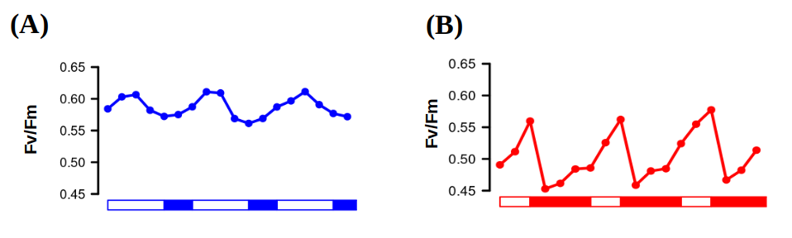Figure 36. **Photosynthetic efficiency rhythmic oscillations.** Fv/Fm oscillating values used as an estimation of PSII performance and, thus, photosynthetic efficiency under three consecutive days of summer (A) and winter (B) photoperiods.

#### Integration of photosynthesis efficiency rhythmic profile with multi-omics data

Photosynthesis is a complex process involving numerous proteins and different metabolic pathways strongly depend on its execution. Photosynthesis entails an electron transport chain consisting of three major protein complexes: Photosystem II, cytochrome b6f, and Photosystem I. These complexes facilitate the transfer of electrons, generated through the cleavage of the water molecule to their final acceptor, NADP, generating the NADPH required for biosynthetic reactions. The energy derived from this transport enables the pumping of protons into the chloroplast lumen, ultimately leading to ATP synthesis as they return to the stroma via ATP synthase. NADPH and ATP are needed to fix CO2 and generate carbon compounds, within the Calvin cycle, which can be stored as starch reserves (Fig. 37-A). In higher plants, the circadian clock participates in coordinating different physiological processes like photosynthesis, carbon fixation and starch biosynthesis (de los Reyes, , et al., 2017; Farré & Weise, 2012; Graf et al., 2010)⁠. The Fv/Fm rhythmic profiles presented were integrated with the proteomics and transcriptomics data of genes associated with the PSII, which are listed in Fig. 37-B. This integration provided a holistic understanding of how these processes respond to and anticipate to seasonal and diurnal cycles in *Ostreococcus tauri* (Fig. 37-38).

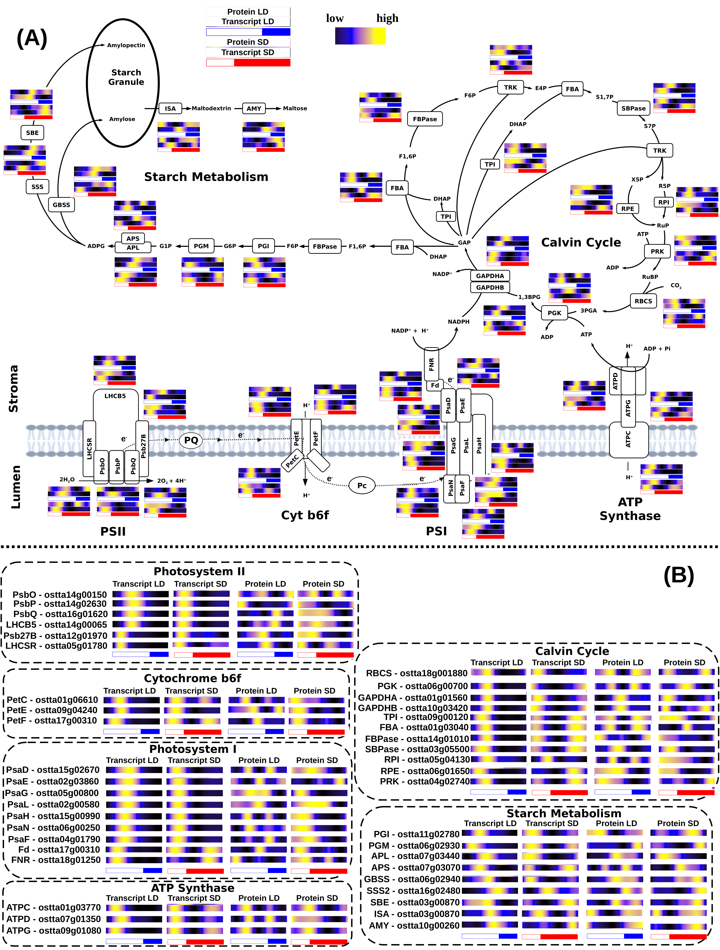Figure 37. **Integration of multi-omic data of enzymes and proteins involved in photosynthesis, Calvin cycle and starch biosynthesis.** (A) Schematic representation of the metabolic pathways and (B) organized list of genes IDs involved in them, including protein abundance and gene expression profiles of each enzyme.

Under summer photoperiod, no temporal offsets were observed between the time points of maximum transcript and protein abundance and the highest Fv/Fm values (Fig. 38-A). The observations suggested that, during the summer photoperiod, genes were promptly translated as soon as they were transcribed, leading to an increase in photosynthetic efficiency through *de-novo* protein synthesis. Conversely, during the winter photoperiod, as it was discussed in Chapter 3, there was a short gene-protein temporal offset and the maximum photosynthetic efficiency occurred a few hours after the maximum gene expression level (Fig. 38-B).

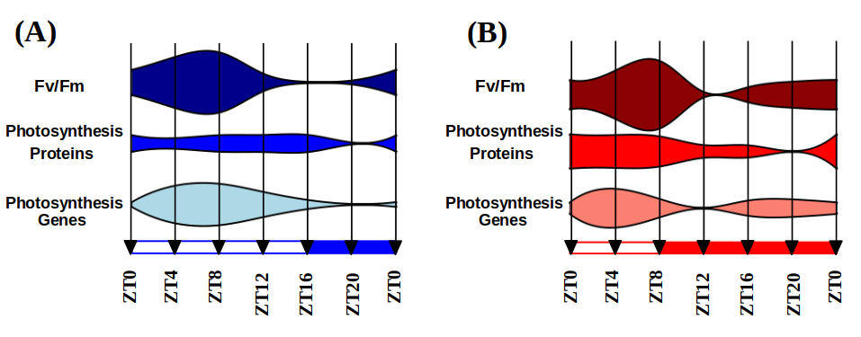Figure 38. **Integration of Fv/Fm oscillations with multi-omic data.** Fv/Fm measurements were integrated with multi-omic data from proteins and genes related with photosynthetic efficiency under summer (A) and winter (B) photoperiod.

. For example, the early increase in gene expression at the beginning of the night, observed in genes encoding components of the Oxygen Evolving Complex PSII subunits O, P and Q (PsbO, ostta14g00150; PsbP, ostta14g02630; PsbQ, ostta16g01620), among others, (Fig. 37-B) resulted in a corresponding increase in protein abundance and Fv/Fm values during the second half of the night with a ~4 h offset (Fig. 38-B).

Rhythmic profiles with a 12-hour period (two peaks every 24 hours) were observed not only in Fv/Fm but also in the gene expression profiles under the winter photoperiod (Fig. 38-B). Profiles with two peaks under SD conditions were found in genes such as Protein Electron Transfer C (PetC, ostta01g06610), Ferredoxin (Fd, ostta17g00310) and ATPase delta subunit (ATPD, ostta07g01350) coding for key components of Cytochrome b6f, Photosystem I and ATP Synthase (Fig. 37-B). These genes constitute examples of the emergence of two peaks under SD conditions (Fig. 26-A), one induced by the photoperiod, maintained only under LL, and the other one induced by the skotoperiod, maintained only under DD. Specifically in photosynthesis, one expression peak occurred during the early morning, enhancing photosynthetic efficiency during the hours of maximum irradiance. The second expression peak took place during the night, inducing the anticipation of the photosynthetic machinery before sunrise. These findings suggest that the response of the photosynthetic machinery in anticipation to the photoperiod is transcriptionally regulated in *Ostreococcus tauri* and likely was established early in the green lineage.

In general, genes involved in photosynthesis electron transport chain and Calvin cycle were consistently expressed early in the morning, under both summer and winter photoperiods (Fig. 37-B). The expression of those genes seems to be unaffected by the photoperiod, since it has been also observed in *Ostreococcus* under a neutral photoperiod, consisting in 12h of light and 12h of dark cycles (Monnier et al., 2010)⁠. In fact, genes coding for key components on the Calvin Cycle such as Glyceraldehyde-3-phosphate dehydrogenase A (GAPDHA, ostta01g01560) and Fructose-1,6-bisphosphate aldolase (FBA, ostta01g03040) are examples of *bona fide* circadian genes exhibiting rhythmicity under both summer and winter photoperiods, as well as free-running conditions of constant light and constant darkness (Table bonafide?).

Not only the genes coding for PSI, PSII and antenna complexes exhibited 12 h period expression profiles during winter photoperiod. Numerous genes, involved in Calvin cycle and starch metabolism exhibited these expression profiles as well (Fig. 37-B). It suggested that the transcriptional regulated anticipation to the short light hours during winter photoperiod affected all processes related with photosynthesis, including not only the electron transport chain but also the Calvin cycle and starch metabolism.

In addition, protein abundance rhythmic profiles with 12h period were observed under summer photoperiod along numerous genes listed in Fig. 37-B. The secondary peaks observed in these proteins were not induced by an increment in the transcription level of their corresponding gene (Fig. 37-B). Multi-omics integration of the results presented in this thesis sew that this phenomenon was present in all Calvin cycle enzymes and some proteins from the photosynthetic electron transport chain (Fig. 37-B). These 12h period profiles are not transcriptionally regulated as the ones described in winter photoperiod, since its encoding transcripts describe only one peak of expression per day (24 h period) (Fig. 37-B). The mRNA rhythmic profiles of enzymes from the Calvin cycle are in agreement with previously published data in plants, both showing a 24 h period (Pilgrim & McClung, 1993)⁠. It suggested that a post-translation regulatory mechanism was causing this 12h period profile in proteins involved in photosynthesis during long photoperiods (including summer and neutral ones) in both microalgae and plants.

#### Integration of starch content diel oscillations with multi-omic data

The accumulation and degradation of starch have been described to be circadian regulated, since periodic oscillations of its content was observed in photosynthetic organisms as *Chlamydomonas* and *Arabidopsis,* as well as a rhythmic gene expression profile of the enzymes involved in the process (Flis et al., 2019; Geigenberger, 2011; Kötting et al., 2010; Ral et al., 2006; Smith et al., 2004; Sulpice et al., 2014)⁠. *Chlamydomonas* reached its maximum starch content few hours after sunset (Ral et al., 2006)⁠, while *Arabidopsis* reaches it exactly at sunset (Feugier & Satake, 2013; Kötting et al., 2010)⁠. In both organisms, starch started to accumulate during the light hours, until amylases (AMY) were activated and its degradation started. Starch content must be considered as the result of a controlled balance between its degradation, by AMY, and its synthesis, by ADP-glucose pyrophosphorylase with its small and large subunit genes (APS and APL) (Fig. 37-A).

Starch content in *Ostreococcus tauri* under diurnal cycles was also rhythmic with a 24h period (Fig. 39-A) with a p-value < 0.05, which aligned with the periodic oscillations described in *Arabidopsis* and *Chlamydomonas*. However, *Ostreococcus* did not reach its maximum starch content around sunset as they did. Instead, the maximum starch content aligned with the high irradiance hours and it decreased gradually after that point, under both photoperiods (Fig. 39-A). These results suggested that there was not a conserved starch content temporal program throughout the green lineage, since its degradation started at different times of the day depending on the organism.

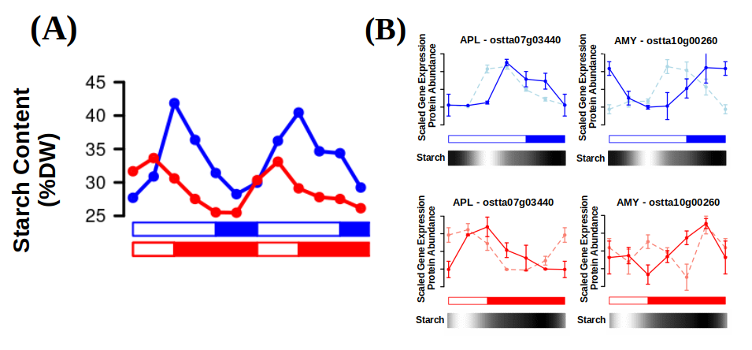Figure 39. **Multi-omics integration of starch periodic oscillations.** (A) Starch content profile under summer photoperiod (blue) and winter photoperiod (red). (B) Scaled gene expression profiles (lighter dashed lines) and protein abundance profiles (darker solid lines) of the main enzymes involved in starch synthesis (glucose-1-phosphate adenylyltransferase, APL - ostta07g03440) and degradation (amylases, AMY - ostta10g00260). Starch content is represented as a color block that gradually changes from black (low starch content) to white (high starch content).

However, which seemed to be conserved were the differences between photoperiods. In *Ostreococcus*, starch degradation during winter photoperiod appeared to be executed more slowly than during summer photoperiod and a higher content in starch was reached during summer photoperiod, as it has been also described in plants (Feugier & Satake, 2013; Geigenberger, 2011; Kötting et al., 2010; Sulpice et al., 2014)⁠,

The starch temporal program observed in *Ostreococcus tauri* (Fig. 39-A) aligned with the transcriptomics and proteomics data generated and analyzed in this thesis*.* Under both summer and winter photoperiods, starch content reached its maximum at midday, despite the abundance of enzymes involved in starch biosynthesis, like APL (ostta07g03440), peaking several hours later, toward end of the day (Fig. 39-B). The halt in starch increase and the subsequent decrease in its content could be attributed instead to the activation of the genes encoding enzymes involved in starch degradation, like AMY (ostta10g00260). The consequently increase in abundance of the corresponding proteins during the second half of the day under both photoperiod was, thus, coincident with the decrement in starch content (Fig. 39-B).

In chapter 3, gene-protein offsets were hypothesized to be dependent on the photoperiod of entrainment and the biological process where those proteins are involved. Our results showed how temporal offsets of genes involved in the same biological process increased under short photoperiod, indicating a common regulation under seasonal cycles. In starch biosynthesis, offsets of APL (~4 h under both photoperiods) and AMY (8 h in summer and 12 h in winter) were different and they increased differently under short photoperiod (Fig. 39-B). This supported previous results in plants, that suggested that synthesis and degradation of starch were complex processes regulated by different mechanisms (Geigenberger, 2011; Hartman et al., 2023; Kötting et al., 2010)⁠⁠. In addition, both APL and AMY protein abundance profiles were coincident with their gene expression profile, except for the described offset (Fig. 39-B), showing that at least transcriptional regulation was one of the mechanisms that might contribute to starch synthesis-degradation balance in *Ostreococcus tauri* as it has been observed in *Arabidopsis* and other plants (Finegan et al., 2022; Geigenberger, 2011; Kötting et al., 2010; Sorokina et al., 2011)⁠.

### Other metabolic pathways of *Ostreococcus tauri* showing periodic oscillations under diurnal and seasonal cycles

#### Carotenoids biosynthesis in Ostreococcus tauri under diurnal and seasonal cycles

Carotenoids are a group of isoprenoid pigments that are widely distributed among various organisms, including microalgae and plants. Some of these pigments are associated with light-harvesting complexes and perform a crucial role in photosynthesis by efficiently absorbing light energy and transferring it to reaction centers. In addition, carotenoids exhibit antioxidant properties, safeguarding the organism against potential harm induced by excessive light exposure and environmental stress (García-Plazaola et al., 2017; T. Sun et al., 2022)⁠. The expression of genes associated with carotenoid biosynthesis is intricately regulated by the circadian clock in both plants and algae. This circadian regulation ensures that the production and accumulation of carotenoids aligns with the physiological demands and environmental conditions. Optimal timing of carotenoids production maximizes their effectiveness in light absorption, energy transfer, and antioxidant protection. (Covington et al., 2008; García-Plazaola et al., 2017; Pan et al., 2009; T. H. Sun et al., 2010; Zhang et al., 2022)⁠.

Besides to their role in photosynthesis, carotenoids have considerable nutritional value for humans. Certain carotenoids, including β-carotene, possess the capacity to be converted into vitamin A, a vital nutrient essential for maintaining vision and bolstering the immune system. Furthermore, specific carotenoids, such as astaxanthin, have exhibited promising potential in promoting health, as they have been associated with reducing the risk of certain cancers and cardiovascular diseases. (Eggersdorfer & Wyss, 2018)⁠.

Microalgae have emerged as a promising source for large-scale production of carotenoids. However, the full potential of this technology has not been reached due to limited understanding of the molecular mechanisms underlying carotenoid biosynthesis. Over the past two decades, numerous research groups have been studying growth conditions, microalgae metabolism and optimizing photobioreactors design to maximize carotenoid production while minimizing associated costs (Del Campo et al., 2004; Hoys et al., 2021; Sierra et al., 2008)⁠.

Industrial-scale cultivation of microalgae is predominantly achieved in outdoor settings. Therefore, comprehending the oscillation patterns of carotenoid biosynthesis under diurnal and seasonal cycles becomes crucial for ensuring the maximum carotenoid content at harvesting time, as well as identifying potential gene and protein targets for further optimization. To understand the adaptive nature of carotenoid content to seasonal variations in diel cycles and its implications for optimizing light energy capture, photoprotection and, thus, it’s possibilities of industrial optimization, the transcript and protein abundance profiles of carotenoid biosynthesis genes in *Ostreococcus* were examined. In addition, these profiles were integrated with carotenoid content profiles as biological validation of the results (Fig. 40).

##### Integration of multi-omics data with oscillations described by carotenoids content in *Ostreococcus tauri* under diurnal and seasonal cycles

*Ostreocccus tauri* is rich in widely distributed carotenoids like violaxanthin, antheraxanthin or zeaxanthin. Although specific carotenoids of Mamiellophyceae like micromonal, uriolide or prasinoxanthin are also found in this prasinophyte, being prasinoxanthin the most abundant one (Egeland et al., 1995; Guyon et al., 2018; Six et al., 2009)⁠. Its genome presents genes encoding for the Methylerythritol 4-phosphate (MEP) pathway (Derelle et al., 2006; L. Zhao et al., 2013)⁠, which derives pyruvate to the production of geranyl pyrophosphate (GPP), the main carotenoid precursor (Fig. 40-A). Most genes encoding enzymes involved in the MEP pathway peaked at sunrise under summer photoperiod and during the last part of the night under winter photoperiod, preceding the corresponding protein abundance peaks by 4 hours or less (Fig. 40-B). Similar patterns were observed in the first enzymes of the carotenoid biosynthesis pathway(Fig. 40-A). The progression of the MEP and carotenogenesis pathways allow the cell to produce the main precursors needed for carotenoids production and seems to be transcriptomically regulated in a similar way. In both pathways, enzymes were transcribed during the night under winter photoperiod ensuring the presence of its encoding proteins during the day (Fig. 40-B). From this point, the pathway diverges in two different branches, due to the Lycopene of ε/β cyclase (LCYε/β, ostta14g00700) that seems to be regulated in specific ways depending of the biological function of the carotenoids produced: β-branch, including the xantophylls cycle; and α-branch, including the main antenna carotenoids in prasinophyte (Fig. 40-A) which biosynthesis pathways are still unknow (Guyon et al., 2018; Six et al., 2009)⁠.

Carotenoids content during diurnal cycles under both summer and winter photoperiods have been estimated. The rhythmicity analysis detected rhythmic abundance profiles with periods of 24h in all carotenoids under both photoperiods, except for lutein and violaxanthin, that did not maintain their rhythmicity under winter photoperiod. In general, fluctuations on carotenoids content during winter photoperiod were less drastic, resulting in a lower wave amplitude. (Fig. 40-A).

The xanthophyll cycle, the interconversion between violaxanthin, antheraxanthin and zeaxanthin as a response to light intensity (CITA: también puedes cogerla del paper), was especially active under summer photoperiod, although its activity was also detected under winter photoperiod. The changes in these xanthophylls coincided with the accumulation of transcripts and proteins encoded by genes associated with the xanthophyll cycle, with short temporal offsets (Fig. 40-A). Under summer photoperiod, the maximum protein abundance of violaxanthin de-epoxidase (VDE, *ostta16g00660*) (Fig. 40-B) match the increasing zeaxanthin content during the light hours (Fig. 40-B) and match the increasing content of violaxanthin during the dark hours (Fig. 40-C). These enzymes are transcribed sequentially with a clear temporal regulation. βCH gene was expressed early in the morning, sequentially followed by ZEP and VDE in that specific order under both photoperiods (Fig. 40-B). However, there was not a significant amount of zeaxanthin being accumulated during winter photoperiod. Instead, a high level of violaxanthin without drastic variations was maintained during diurnal cycles (Fig. 40-A). It suggested that xantophylls cycle was not enhancing the production of zeaxanthin due to the limited daylight hours during winter. In some studies regarding irradiance stress in *Ostreococcus* and other prasinophytes variations in xantophylls contents have been described, in a similar way to the ones observed in this thesis, due to short light periods (Böhme et al., 2002; Guyon et al., 2018; Six et al., 2009)⁠.

In general, the enzymes of the β-branch pathway seemed to present a strong transcriptomic regulation to sequentially achieve their roles at the right time. However, these transcriptomic regulation did not reach the physiological level under winter photoperiod (Fig. 40-A), where xantophylls content was similar to the ones observed in low irradiance stress experiments (Böhme et al., 2002; Guyon et al., 2018; Six et al., 2009)⁠ suggesting that despite the strong temporal transcriptomic regulation that was also reflected in proteins abundance profile (Fig. 40-C), there were other regulatory pathways that balance xantophylls production under certain conditions like winter photoperiod.

Regarding pigment of the α-branch biosynthesis pathway, a lack of lutein during winter photoperiod was observed (Fig. 40-A). However, during summer photoperiod lutein was accumulated during the light hours, followed by the increment of prasinoxanthin content after sunset (Fig. 40-C). Lutein and prasinoxanthin contents behavior under summer photoperiod were similar to the obtained in irradiance stress experiments in other prasinophytes. In *Mantoniella squamata* the accumulation of lutein was linked to irradiance stress and its following conversion to prasinoxanthin when the stress condition was over (Böhme et al., 2002)⁠.

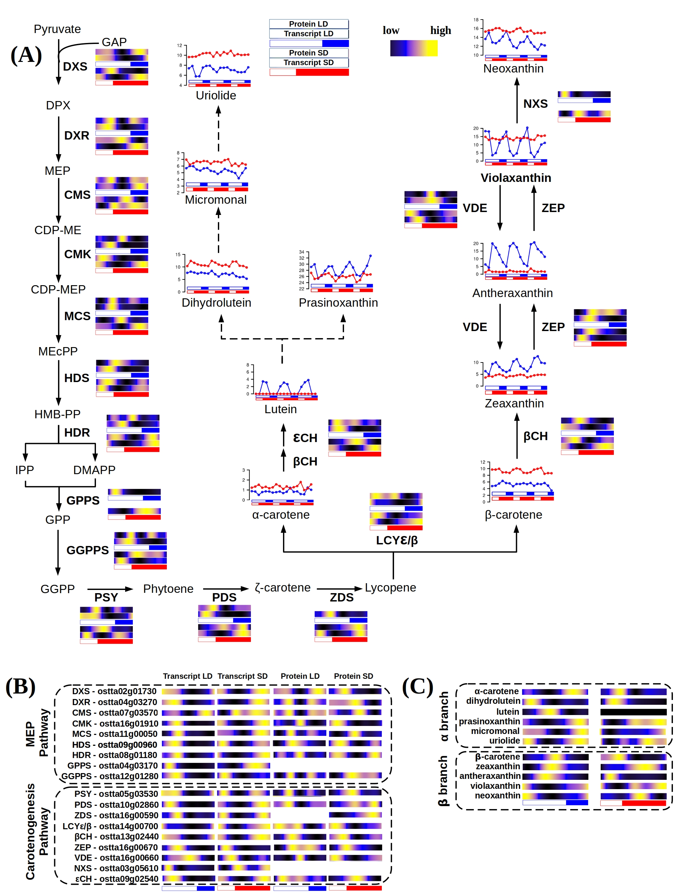Figure 40. **Integration of multi-omics data from the complete carotenoids biosynthesis pathway and carotenoids content of Ostreococcus tauri.** (A) Schematic MEP pathway and carotenogenesis, α-branch biosynthesis pathway according to (Egeland et al., 1997). (B) Organized list of the gene IDs involved in these pathways including multi-omic data. (C) Organized visualization of content oscillations of each carotenoid from the β and α branch.

Although the α-branch biosynthesis pathway is still unknow there are some hypotheses about the inter-conversion of lutein-prasinoxanthin (Egeland et al., 1997)*⁠.* This could be supported by our results in *Ostreococcus* sincethe content of lutein and prasinoxanthin seem to be linked, not only under irradiance stress, as it has been described in previous published studies (CITA), but under different photoperiods as well. However, the enzymes involved in the interconversion of these carotenoids remain to be identified, and a comparison of their gene expression and protein accumulation was not feasible in this study. In summary, *Ostreococcus tauri* carotenogenesis present the common characteristics of a process regulated by the circadian clock, as being able to adapt to different photoperiods and presenting an anticipation to diel changes. However, content in carotenoids seem to also depend on other regulatory pathways besides the circadian clock, as some of the changes observed under the photoperiods studied align with high and low irradiance experiment results.

#### Nitrate assimilation under diurnal and seasonal cycles in Ostreococcus tauri

Nitrogen is an essential component in biomolecules for all living beings. In the atmosphere, N2 is the most abundant form of nitrogen. This gas is dissolved in water ecosystems but is inaccessible for microalgae. In fact, nitrogen is a major limiting nutrient of marine phytoplankton (Barros et al., 2005; Mittag, 2001; Sanz-Luque et al., 2015)⁠.

*O. tauri* have developed competitive mechanisms to ensure nitrogen assimilation in the marine ecosystem. It can grow on nitrate, ammonium and urea, and complete sets of genes allowing transport and assimilation of these substrates have been identified in its genome (Blanc-Mathieu et al., 2014; Derelle et al., 2006)⁠. In the previous chapters of this thesis, nitrate assimilation has been identified as one of the biological processes which genes and proteins present significant rhythmic profiles under diurnal cycles, with larger offset between gene expression and translation. In this section, enzymatic activity of two of the main enzymes involved in the nitrate assimilation pathway were integrated with the transcript and protein abundance profiles of the complete pathway. These results gave new insights on the adaptive response of this assimilation process to seasonal variations in diel cycles and its implications for optimizing nutrient uptake and metabolism.

##### Integration of key enzyme activities from nitrate assimilation pathway with multi-omic data

Nitrate is first transported into the cell by Nitrate Transporters 2 and 3 (NRT2, ostta10g00950 and NRT3, ostta10g00940), followed by its reduction to nitrite by Nitrate Reductase (NR, ostta10g00920). Nitrite is further reduced to ammonia by Nitrite Reductase (NIR, ostta10g00930). The central part of nitrate assimilation is played by the Glutamine Synthetase (GS, ostta01g05020) and Glutamine Oxoglutarate Aminotransferase (GOGAT, ostta14g01900) cycle, which converts inorganic nitrogen, ammonia, into glutamine and glutamate (Fig. 41-A), a central precursor for the biosynthesis of nitrogen-containing compounds such as amino acids and nucleotides (Sanz-Luque et al., 2015)⁠.

During summer photoperiod, gene expression profiles of NRT2/3, NR and NIR reached their maximum at dawn (ZT0), while their protein abundances peaked 8 hours later at midday (ZT8), coinciding with the time point of maximum light irradiance. GS and GOGAT gene expression and protein abundance profiles were almost coincident, reaching their maximum at the beginning of the day (ZT4) without noticeable temporal offsets between them.

increase in protein abundance was detected at the end of the day (ZT12) for both GS and GOGAT (Fig. 41).

Figure 41: **Multi-omics integration of nitrate assimilation pathway.** Schematic nitrate assimilation pathway and list of the gene IDs involved including protein abundance and gene expression profiles of each enzyme.

In contrast, under winter photoperiod, all genes encoding the transporters and enzymes involved in nitrate assimilation showed their maximum expression level during the first part of the night (ZT12-ZT16), preceding their protein abundance peaks at dawn (ZT0) or midday (ZT4) by 8 hours or more. Notably, GOGAT gene expression displayed a bimodal pattern under SD conditions, maintaining the peak observed under LD at ZT4 besides the new peak at ZT20. Therefore, GOGAT gene expression constitutes an example of the emergence of complex expression patterns under summer photoperiod consisting of two gene expression peaks per day (Fig. 41).

Circadian oscillations in expression and activity of the first enzyme of this pathway (NR) have been described in *Arabidopsis* and other crop plants as maize or tomato (Lillo et al., 2001; Lillo & Ruoff, 1989; Tucker et al., 2004; Z. Yang & Midmore, 2005)⁠. In fact, light is apparently an important factor for NR to maintain its rhythmic behavior. Rhythms in NR activity or NR gene expression profiles were shown to persist only in continuous light in plants (Lillo et al., 2001; Lillo & Ruoff, 1989)⁠. These results are in agreement with the transcriptomic data obtained in this work, where NR gene expression rhythmic profiles, as well as other enzymes involved in this pathway, are maintained only under light-dark cycles and constant light.

To validate these results, the enzymatic activity of NR and GS are measured throughout complete diel cycles under summer and winter photoperiods. These measurements presented a significant rhythmic profile with a p-value lower than 0.05 and an almost non-existent offset between their protein abundance profiles and their activity profiles was found (Fig. 42).

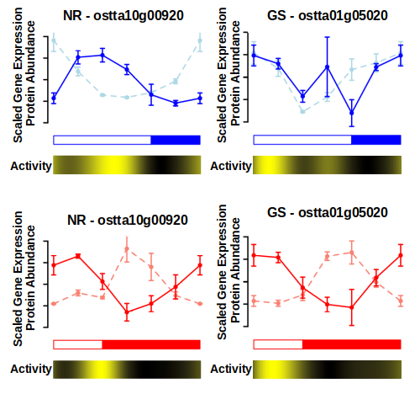Figure 42. **NR and GS rhythmic activity compared with its proteomic and transcriptomic data generated.** Transcript (lighter color) and protein (darker color) abundance profiles for Nitrate reductase (NR, left) and Glutamine Synthetase (GS, right) under LD conditions (top, blue) and SD conditions (bottom, red). Heatmaps are incorporated below to represent the changes in enzymatic activity of these enzymes. Black represents low activity and yellow??? high activity.

The huge transcriptomic anticipation observed was adjusted by the clock taking in count the large offset between gene expression and translation described by the enzymes involved in this pathway. In fact, although genes were transcribed at different times under winter and summer photoperiod, proteins reached their maximum abundance level at a similar time of the day in both cases (Fig. 41, 42). This is an example of how *Ostreococcus* adjust its transcriptional program in order to ensure the presence of proteins at the exact right time, in spite of their specific translation offset.